**Memo**

**Senior Design**

ENG EC 463

To: Professor Pisano

From: Team 9

Team: Aerobatic BlackBox

Date: 4/29/22

Subject: Customer Installation Report

**1.0 Details of Customer installation**

* Dates: Apr 10, 2022
* Location: Mansfield Municipal Airport
* Members present: Pai Liu, Xinyu Liu, Darcy Meyer
* Customer present: Dr. Kenneth D. Sebesta
* Aircraft: Citabria 7ECA

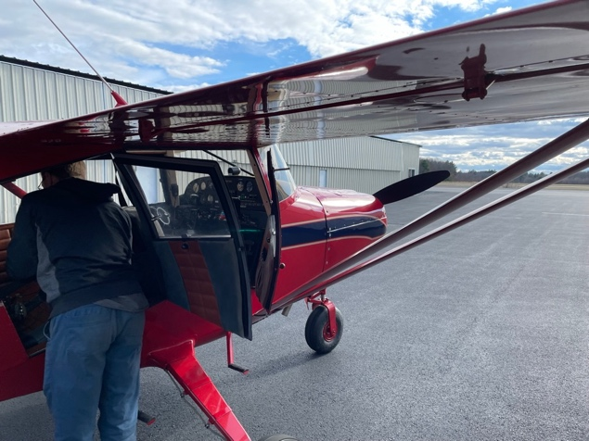

**2.0 Requirements:**

2.1 List of Requirements

**Hardware**

* GPS: Cold start under 5 mins, and hot start under 2 seconds.
* IMU: Successfully record the yaw, pitch, roll angle correctly.
* Dial Camera: Need to be install to visual both airspeed dial and tachometer dial.
* Polit input Camera: Need to be install to visual both flight stick and rudder cable.
* Touch Screen: need to be install a place where pilot can easily access.

**Software**

* User Interface: UI should be display through the touch screen, and can start and stop the program.
* Camera Calibration: This software should start the calibration process, and be adjust by pilot.
  1. **Original Product**

The original product used BerryGPS-IMU for the GPS module and IMU module. However, during the custom installation and on plane testing. We found that the GPS module need more then 20 min for cold start and fix the location, which it does not meet our requirements. And the IMU data from BerryGPS-IMU is different from what we expected, which it is does not meet our requirement. As the result, after second prototype testing, we changed our GPS module and IMU module from BerryGPS-IMU to ublox-M9N(GPS) and MPU9255(IMU). Other hardware meets our requirements. The graph below is the original product overview.

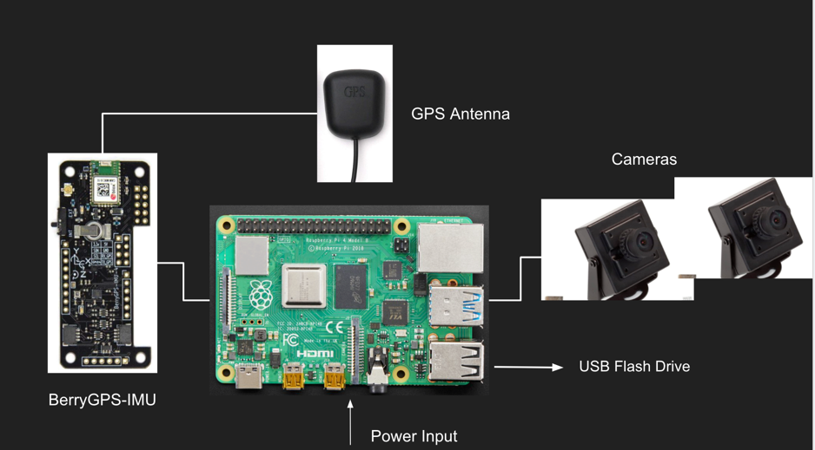

* 1. **Final Product**

The final product contents all the new hardware such as ublox-M9N and MPU9255. The new GPS during the test were able to fix under 1mins for cold start and under 1 second for hot start. The performance meets our requirements. And new MPU also reads the right data. The graph below is our final product overview. And this is the one we bring to installation and on-plane testing.

* 1. **Product Installation**

During the installation we first locate the upper left corner for installing our Blackbox body.

The photo below is the upper left corner of the cabin

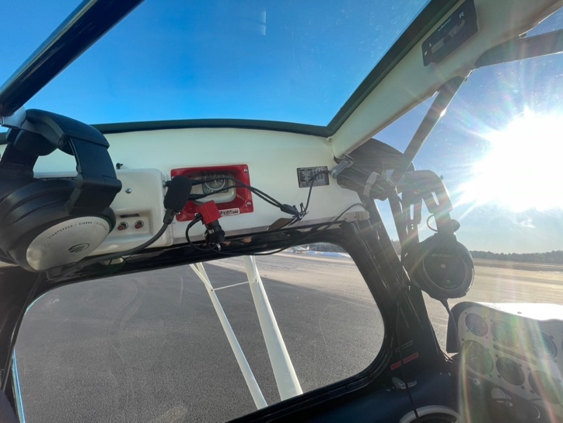

Second, we locate the top bar for installing Dial camera, and the photo below shows the camera view from the top bar to visualize two dials.

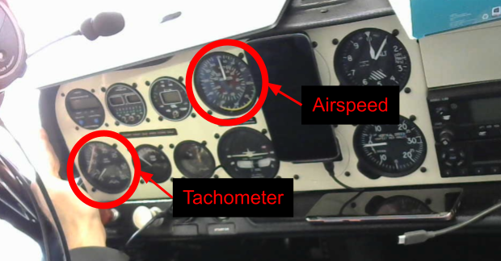

Finally, we located the top roof in back seat to install pilot input camera, and the photo below shows the camera view from the roof to visualize flight stick and rudder cable.

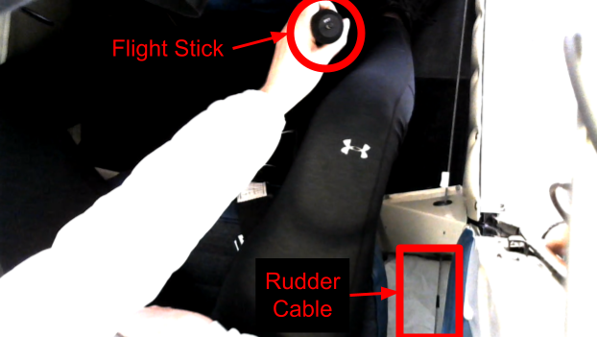

1. **Testing & Future Plan**

**3.1 Testing**

During the testing, we found two problems, the first is the filter of IMU, cause during zero gravity test, the 3D image of plane lose its orientation, and start spin. The second problem is camera is not in auto exposure mode, this will case the video over exposed during high brightness condition. other hardware and software work as we expected.

**3.2 Future Plan**

The overall installation is successfully done. In the future we will update a suitable filter for AHRS system, and change the camera setting to auto exposure mode.